Welcome to Sixth Social Studies!

Contact Information
Ms. Wildermuth
6th Grade Social Studies
Email: Raven.Wildermuth-Akali@cobbk12.org
Blog: https://mswildermuthsssclass.weebly.com/
My preferred contact is through email.

Units of Study
Each unit follows the same instructional sequence. The students will study the Geography, Culture, History, Economics, and Government of each region. In 6th grade, your student will study Europe, Canada, Latin America, and Australia. We spend the first semester on the enduring understandings of Social Studies and Europe. The students cover the remaining regions of the world in 7th grade World Studies.

The units and essential questions are as follows…

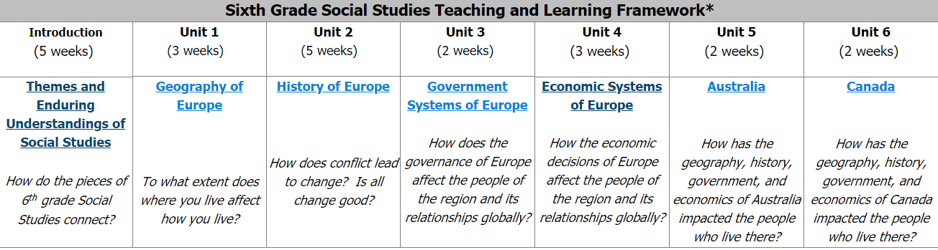
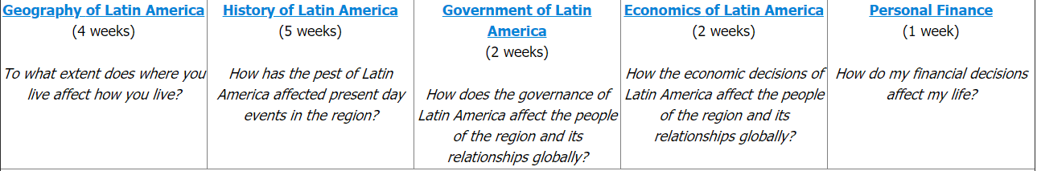

Enduring Understandings/ Priority Standards
In Social Studies, the students focus on enduring understandings in Social Studies. These themes appear in every lesson and extend into real world application. The 6th grade enduring understandings are listed below…
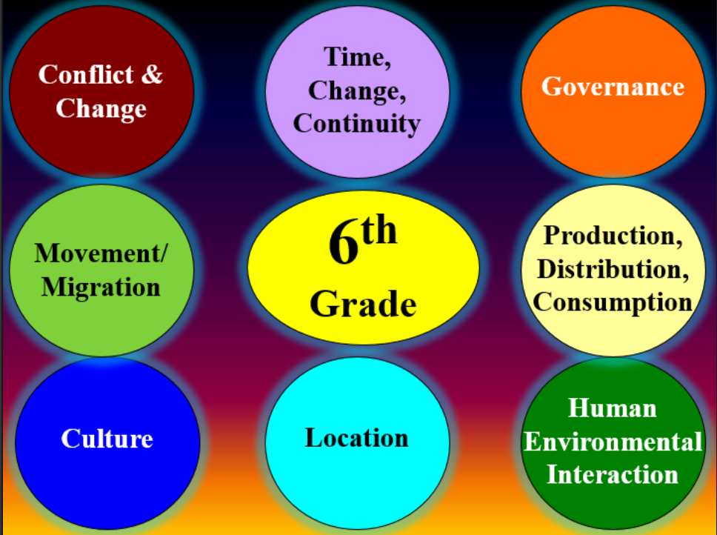

Grading Scale and Categories
Formative Assignments (classwork, homework, quizzes, warm ups) = 70% of total grade
Summative Assignments (tests, projects, essays) = 30% of grade
A = 90 and above
B = 80-89
C = 74- 79
D = 70- 73
F = 69 and below

Grade Recovery
Grade recovery will be permitted on summative assessments only. The purpose of grade recovery is to give the student an additional opportunity to show that he/she has mastered the standards of the course. The following rules will apply for this process.
1. To be eligible to take the retest, students must complete a process of remediation, including but not limited to Saturday School, before and/or after-school tutoring, test analysis, or on-line remediation. The method of remediation will be determined by your teachers.
2. Only one retest is permitted per summative assessment.
3. The retest will not be the same as the original.

Late Work
For every day an assignment is late, teachers may deduct a total of 5 points per day, up to 5 days that an assignment is late. If after the fifth day the assignment still has not been turned in, the student will receive a failing grade until they make up the work. Students with failing grades may be required to attend Saturday School for grade recovery, or before and/or after-school tutoring. Students have until 10 business days to turn in work after the end of a grading period.

Absences
Students who are absent when an assignment is made will be given the same number of days to complete the make-up work as they were absent, not counting the day of return. Make-up of graded work will be as scheduled with the teacher. Students have until five (5) days prior to the end of the grading period to turn in missing work. Assignments made or announced prior to a student’s absence, including tests/quizzes, that are due on the day of the student’s return will be due at that time. (Quizzes and tests will be taken with class.) Homework and any other make up work will be accepted according to school policy. Students are responsible for requesting and following through on make- up work, not the teacher!!!

Blogs

6th Grade Social Studies – http://gms6thgradesocialstudies.weebly.com/
Personal Blog - https://mswildermuthsssclass.weebly.com/

My blog will be updated weekly at a minimum. Please check my blog for missing assignments, interactive activities you can do at home, classwork, and any other materials I deem necessary to ensure your mastery of the content standards. These blogs are an added benefit for you, the student, to ensure you are receiving every tool possible to help you succeed. If you are absent, please check your content-specific team blogs first for the work you missed. Please use my blog regularly.

Welcome to 6th Grade Social Studies!

Please sign and return by: __________________

I understand the course requirements. My student understands the expectations of
Ms. Wildermuth and of the core content courses at Griffin Middle School.

Parent Name (print): _________________________________________

Parent Signature: ___________________________________________

Parent Contact Information
Phone: ________________________
Email: _________________________
Preferred method of contact (circle): email or phone
Would you like to be contacted for volunteer opportunities in my classroom? Yes or no

I look forward to a wonderful year! As always, do not hesitate to email me with questions or concerns.

Raven Wildermuth-Akali
6th Grade Social Studies
Griffin Middle School
Raven.Wildermuth-Akali@cobbk12.org

“In diversity there is beauty and there is strength.” – Maya Angelou

